ADC(Analog to digital converter)

Configuration in STM32CUBEMX:

1.Select SYS->serial wire.

2.Select ADC1 ->select IN0 (Pin PA0)

3. Click on configuration->Analog->click on ADC1 ->click on parameter settings and make the following changes:

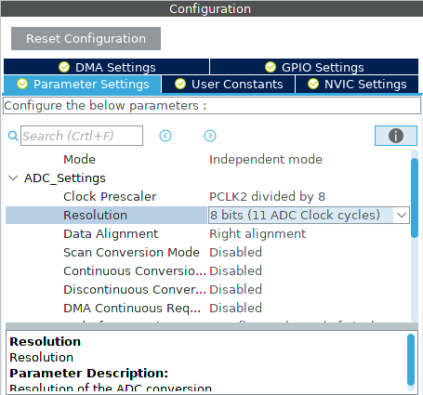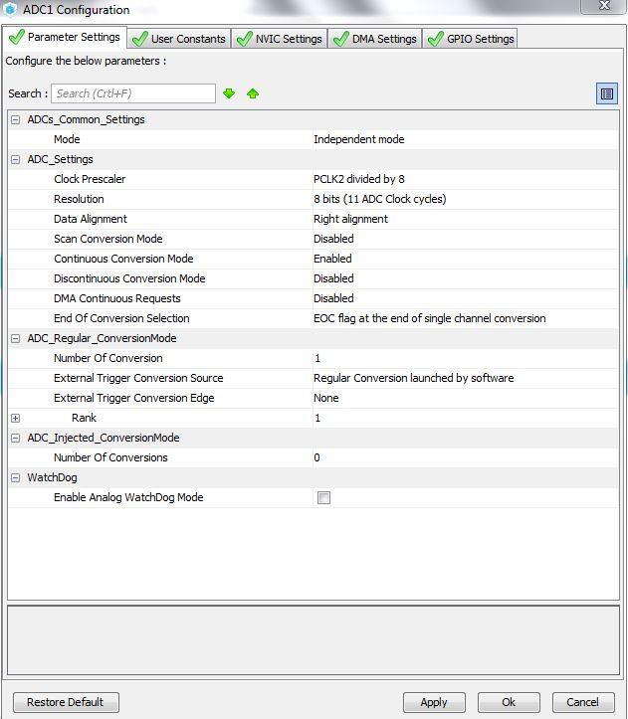

4.Click on DMA setting->Add->select ADC1->select mode circular->Apply and OK.

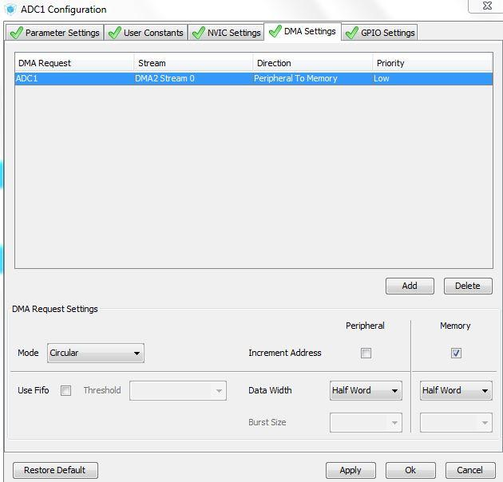

5. Then click on Apply and OK and generate code.

6. Open main.c make the following changes in code .

7.Define the uint32_t adcval in //USER CODE BEGIN 0//

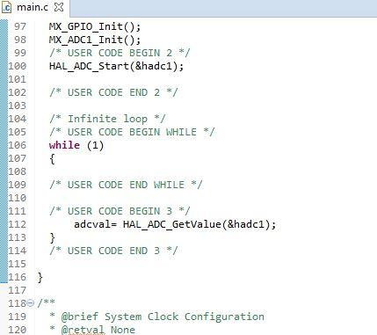

8.Build the project and Run.